AES (Advanced Encryption Standard)
Prabhat Kumar Malviya
2101CS58

AES is a symmetric key encryption algorithm used to secure data. It works with 128, 192, or 256-bit keys and processes data in 128-bit blocks.

Working Mechanism: Step-by-Step
Input and Key Preparation
- Input Block: The plaintext is divided into 128-bit (16-byte) blocks.
- Key Expansion: The key is expanded into multiple round keys using a process called the Key Schedule. The number of round keys depends on the key length:
  - 10 rounds for 128-bit keys.
  - 12 rounds for 192-bit keys.
  - 14 rounds for 256-bit keys.

Initial Round
The plaintext is XORed with the first round key:
- AddRoundKey: Each byte of the plaintext is XORed with the corresponding byte of the round key.

Main Rounds
Each main round consists of the following four operations:
a. SubBytes (Byte Substitution)
- Each byte in the 4x4 state matrix is replaced using a substitution box (S-Box), which is a precomputed lookup table designed to provide non-linearity and resistance to attacks.
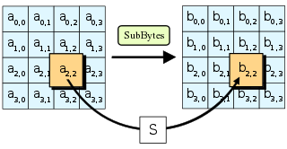
b. ShiftRows
- Rows of the state matrix are shifted cyclically:
  - Row 0: No shift.
  - Row 1: 1-byte left shift.
  - Row 2: 2-byte left shift.
  - Row 3: 3-byte left shift.

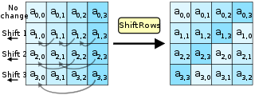
c. MixColumns
- Each column of the state matrix is transformed using a mathematical function that mixes the bytes to increase diffusion.
(Note: The MixColumns step is omitted in the final round.)
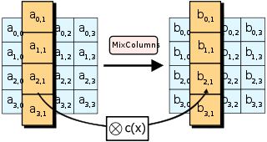
d. AddRoundKey
- The current state is XORed with the corresponding round key.
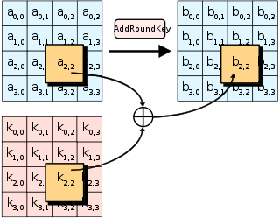

Final Round
The final round excludes the MixColumns step and only performs:
- SubBytes
- ShiftRows
- AddRoundKey
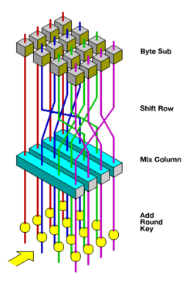

Output
After the final round, the state matrix is transformed into a ciphertext block. This process repeats for all 128-bit blocks of plaintext.
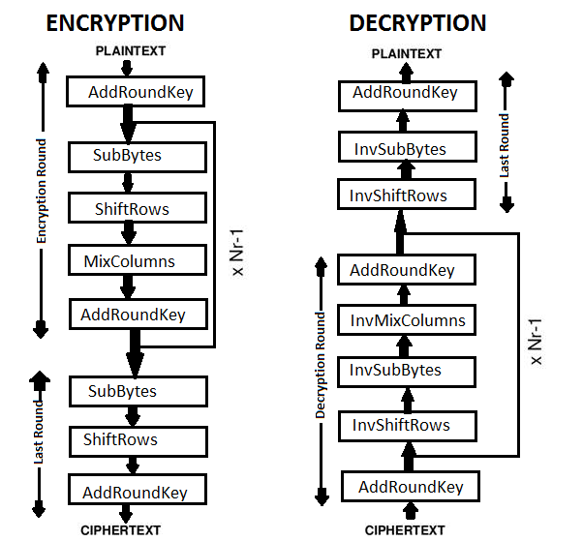

Advantages of AES
- Security:
  - AES is resistant to known cryptographic attacks like differential and linear cryptanalysis.
  - Larger key sizes (192-bit, 256-bit) provide stronger security.
- Efficiency:
  - AES is fast and efficient in both hardware and software implementations.
  - It is widely used in various applications, including TLS/SSL, VPNs, and file encryption.
- Standardized:
  - AES is a globally recognized encryption standard adopted by the U.S. government (FIPS PUB 197).
- Flexibility:
  - AES supports multiple key lengths (128, 192, 256 bits), allowing scalability for different security requirements.
- Lightweight:
  - Suitable for resource-constrained devices due to its computational efficiency.

Drawbacks of AES
- Symmetric Key Distribution:
  - Both the sender and receiver must securely exchange the secret key, which can be challenging without a secure channel.
- Performance with Large Data:
  - Encrypting/decrypting large volumes of data can introduce latency.
- Quantum Vulnerability:
  - Although not broken, AES might be less secure against quantum attacks (Grover's algorithm can reduce effective key strength).
- Single Point of Failure:
  - If the secret key is compromised, the entire communication is vulnerable.
- Block Size Limitation:
  - AES operates on fixed 128-bit blocks, which may require padding schemes or block chaining modes (e.g., CBC, GCM) to handle data of varying lengths securely.

PERFORMANCE:
